|  |
| --- |
| Portfolio Evidence |
| Large rock formation in rocky landscape under blue sky |

|  |  |
| --- | --- |
| 28/01/19 | Personal Website |

|  |
| --- |
| In this document I will be laying out the evidence and methodology used for creating a personal portfolio website. |

Portfolio Evidence

Personal Website

# Context

I am currently working on a farm and I am looking to move into the web development industry. As I am the only person in my company to be doing web development, my first goal is to find a new work placement to help further my career. As part of this, my first project will be creating a personal portfolio website where I can list my current achievements and a portfolio of my existing work.

## Objective

The objective of this project is to create a website that displays my talents as a web developer. While I already have an existing site, I do not feel it displays the full extent of my knowledge.

The current site is built using the Bootstrap 4 framework, and while it is easy to navigate and displays the information clearly, I feel it could use an update to bring it in to line with my current skill set. I intend to create the new site using HTML, CSS 3 and JavaScript as these are the languages I am currently focusing on.

### Project Plan

For this project I will be following the Software Development Life Cycle (fig. 1). With regards to this, I will be following an Agile workflow methodology, as I feel it will allow for me to rectify any omissions or mistakes that occur during the development process.

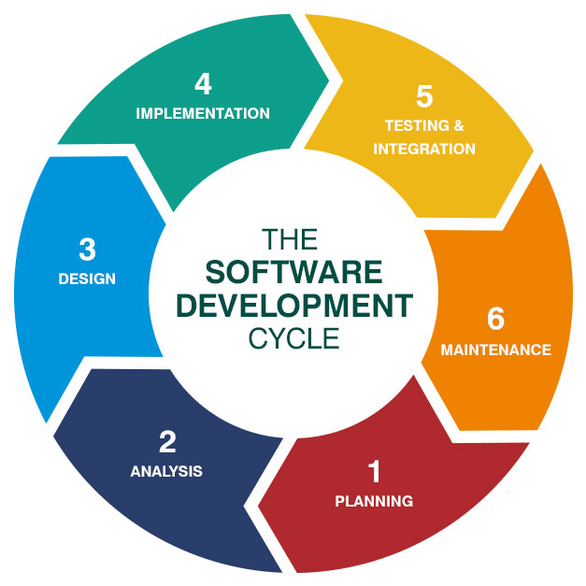

Figure

# Planning

During the planning stage of this project I will be evaluating the tools I will require, the user requirements, the timescale of the project, as well as other items.

I began by creating user stories with a focus group of fellow web developers, to try and give me a feel for who may be using the site and what they were looking for. I then took the information from this focus group and created rough personas that embodied who I saw as the key users. I then created an open card sort exercise to help me determine the key features of the website, and a follow up questionnaire that would give me more feedback from the card sort.

Using the data gathered from the card sort and questionnaire I was able to go back and refine the personas, and update key features to be included on the website.

### Requirements

To evaluate the requirements of the site,

### User Stories

### Personas

### Card Sorts

### Questionnaires